Installer Guide to Completing a Package Label for Space Heater Energy Labelling
The regulation for space heaters includes a ‘package’ label that applies when the product is combined with other system components such as solar thermal or temperature controls. The package label must be produced even if the products are simply combined by an installer as part of an installation.
This means that installers need to produce a ‘package label’ when they install a temperature control with a boiler replacement (and the new Boiler Plus amendments to the Building Regulations require the installation of a temperature control with a combi boiler in an existing property.) This paper focusses on how to complete such a label when adding a temperature control.
Temperature Control Classes
Temperature controls, such as a room thermostat or weather compensator, are deemed to increase the rated efficiency of a space heater (boiler) when installed at the same time.
A simple calculation can work out the efficiency of the 'package' by adding the percentage value for the class of temperature control to the specified efficiency of the boiler.
The classes of temperature controls and the efficiency scores for each are shown below:
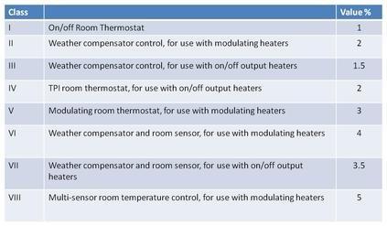

As part of the documentation that will be included with the temperature control is a sheet declaring which class that control belongs to.

Producing a Package Label
BEAMA has produced an online tool to help installers produce a ‘package label’ in three easy steps:
- Enter information from the Energy Label that comes with the boiler
- Enter the temperature control class
- Generate the package label and print or email directly to the customer
This tool is available online at: http://ecoboiler.eu/
If you have done all of the calculations yourself you can also use the Eurpean Commissions Label Generator at: https://ec.europa.eu/energy/en/energy-labelling-tools

