EURIS priorities for industry post Brexit
The EURIS group (European Union Relationship and Industrial Strategy) represents the combined industrial membership of BEAMA and GAMBICA, with additional representation from other aligned Trade Associations. (EAMA, NMI, CESA). The 2000+ companies in the combined membership are represented by a Task Force of 13 companies, plus the executives from the member associations.
Our combined industries have developed and changed completely over the 43 years of EU membership, and are inextricably part of European industry, and thus all the political, legislative and regulatory aspects of EU membership. The ownership and management of member companies, is split between UK national, European and global entities. The decision for the UK to leave the EU therefore, presents a set of major challenges to the whole industry.
This paper is split into a number of sections:
Part 1 - The main policy themes.
Part 2 - The impact on the industry, June – Dec 2016
Part 3 - The surveys and reports generated by BEAMA, GAMBICA and other TAs
Part 4 - The role of EURIS in 2017 and beyond
Part 5 – Real-life examples from members of the EURIS TF

Version 2.0
6/02/2017
howard.porter@beama.org.uk
steve.brambley@gambica.org.uk

Part 1 The main policy areas
The policy areas identified are all essential for the competitiveness and sustainability of the industry members of the EURIS Trade Associations.
- As many aspects of the Single market conditions as is possible need to be maintained over the long term. For product manufacturers, there are specific market requirements, including European product legislation and standardisation, which will still need to be maintained to enable trade with the remaining EU countries.
- A customs regime that allows for the free movement of goods at the lowest or no cost and minimal transport delays, both into and out of the EU and does not add burdensome non-tariff barriers or origin certification requirements.
- Preservation of the current status of existing EU nationals that are employees of companies and their families as soon as possible. The future access to the range of employees required for continuation and growth of UK business relies on continued access to EU citizens.
- An overall deal with the EU which provides equal status and terms for all sectors of UK industry.
- A suitable implementation period to allow for clarification of any new regulatory framework and a continuation of UK input in developing standards, research and other activity in European bodies beyond EU institutions.
- EURIS associations and their members need to be fully involved in the development of any new trade deal with the EU, in particular with reference to our products, software and associated services.
- EURIS associations and their members are committed to assist UK Government to develop and deliver a productive and sustainable future relationship with the EU and its member states.
- EURIS associations have strong influence in Brussels in the product and service areas covered by the relevant industries. The Trade Associations recognise that these links will need to be utilised and where possible increased, as the nature of the UK Government and civil servants’ influence changes.

Part 2 The impact on the industry, June – Dec 2016
The impacts on the EURIS industries in the 6 months following the referendum vote have been varied, but there are some conclusions that can be discussed.
- The price of imported goods has increased by on average 13% year on year. This has affected both the import of components, and finished products. This is due to the weakened pound against the US Dollar, connected Dollar currencies and the Euro.
- These increased costs have now begun to be passed onto customers. Price increases have thus far been limited, but industry reports price increases now being passed on to customers. Reports of between 5-10% price increases are now common across our industries.
- Export into the EU 27 have increased in line with the currency variations.
- Turnover of companies has increased in line with the higher costs of doing business.
- Anecdotal evidence on investment intentions is varied, and is unlikely to settle until later in the leaving process.
The statistics collected by the TAs on behalf of industry are focusing more on the impact of the Brexit vote, and will be a vital monitor on the effects of the leaving process over the next 27 months. Initial conclusions based on 6 months of data are limited, but as the collected data increases a clear picture of the effects on the EURIS industries will emerge.
Many companies are currently developing their policies for the future, based on their experiences in the first 6 months, and by the developing policy landscape. The cooperating Trade bodies will be reporting on the changes that develop, with the impact on the UK economy.

Part 3 The surveys and reports generated by BEAMA, GAMBICA and other TAs
Following the Referendum in June 2016, all the Trade associations in EURIS have consulted with their members on the short and longer term implications of the resultant Brexit process. The survey results and reports are summarised with detailed positions in the Annexes.
Member surveys
- GAMBICA – overall impact survey September 2016
GAMBICA ran a survey with member companies to establish their priorities and actions following the UK voting to leave the European Union on 23rd June 2016. This report analyses the results of the survey.
In terms of priorities, Access to the Single Market came out as highest by a clear margin, ranked number one by 79% of participants and in the top 3 by 92% of participants. It was also ranked number one priority by all sizes of company and both manufacturers and non-manufacturers.
Access to Skilled Workers came out as the next priority, especially for manufacturers and medium / large companies. Influence on Standards was also in the top 3, for both small and large companies and again particularly for manufacturers.
In terms of actions in the shorter term, there was a theme of employment freezes, exchange rate monitoring and postponements of investment decisions. Longer term, the high level of uncertainty is a cause for questioning future investment, expansion and partnerships.
2. GAMBICA/BEAMA WTO survey January 2017
During January 2017, GAMBICA and BEAMA ran a survey to determine how members thought that WTO trading rules would impact their business.
In summary, EURIS industries import more from the EU than they export and think this ratio is likely to increase in the next 3 years.
- We have more importers (91% of members) than exporters (77% of members)
- 54% of importers also re-export, 46% re-exporting to the EU
- Higher value of imports (32% of turnover) than exports (16% of turnover)
- Higher value of EU imports (26% of turnover) than EU exports (8% of turnover)
- Higher likelihood of increased imports (27%) than increased exports (24%)
- 32% of exporters saw significant differences between processes for EU and rest of world
- 75% of participants saw no potential benefit of fewer regulations from EU
Participants were asked to rate the impact of WTO rules on their business from Very Positive to Very Negative. The average results can be seen in the table, where Trade tariffs and Cross frontier admin would have the most negative impact.
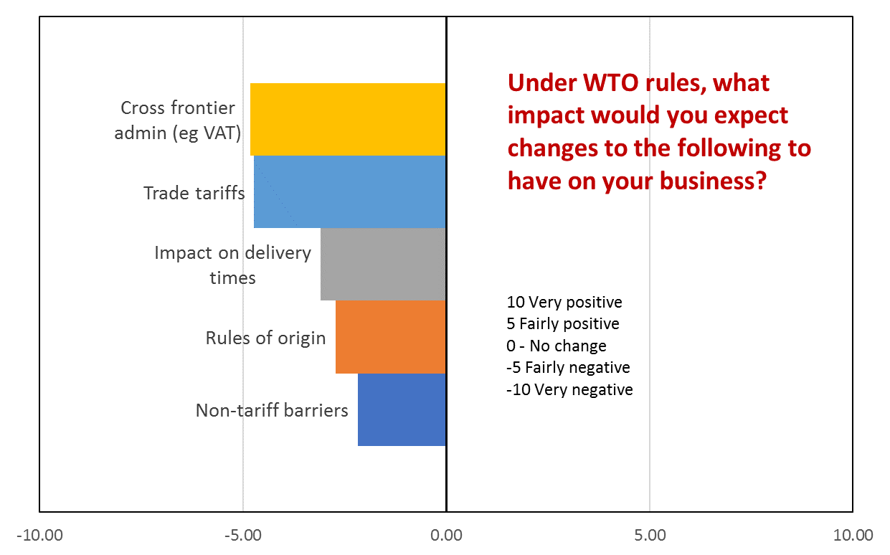
- EAMA surveys
EAMA have surveyed its members as part of their regular state of business reviews, and specifically on the short term effects of the Leave vote.
The initial views of its members (9th November) were:

- Post Brexit, mechanical and electronic engineering companies are looking forward to reduced regulation, but believe that access to the Single Market and skilled workers are more important issues that need to be maintained.
- Basically, manufacturers and non-manufacturers said access to the Single Market was their overwhelming number one priority with support around 80% and nothing else scored even double figures. Both also agreed that access to skilled workers was their second most important priority.
- There was also an increase in exports at the time of the survey.
The most recent state of industry survey was positive, based on the experiences of the previous 6 months.
- Other relevant surveys
There are other industry surveys currently under development, and others will be initialled. These will be added to this initial list as they emerge.

Association papers
Summaries
1 International Trade paper – originating from BEAMA
Issues of concern from broader international trade include:

- Difficulties in being subject to basic WTO provisions in a prolonged interim period between leaving the EU and agreement of trade agreements (noting typically lengthy periods to agree these).
- Potential difficulties in agreeing free trade agreements in a world that is becoming more protectionist and prevalence of one-sided nature of agreements with major markets (e.g. China-Switzerland where China has up to 15 years to remove tariffs while the Swiss have to remove them immediately).
- Uncertainty over what WTO provisions will apply given that much of the UK’s WTO status is subsumed into the EU.
- Risk in new trade agreements granting concessions over technical compliance with safety and quality standards that will damage UK market in engineered products and prevent robust compliance requirements.
- Risk that granting equivalent status to non-EU standards in trade agreements will make the UK ineligible for participation in European standards making.
- Risk that new trade agreements will impose new requirements on UK manufacturers that conflict with existing UK and EU regulatory frameworks.
- Possibility of UK becoming a target for dumping of low value, low standard products.

- European Directives Paper – originating from BEAMA
This paper explores the options for companies whose products and services are covered by European Directives. It concludes the following:
  - Any existing European Directives, associated legislation and standards need to be adhered to. Much if not all of this European legislation is incorporated into UK legislation. Under the Government’s planned, ‘Great repeal act’, it expected that all legislation will remain UK regulations.
  - Any Directive and subsequent legislation that is currently under development and due for implementation before April 2019 will receive the same inputs from UK industry representatives. If implemented in this timescale it will be treated as the existing legislation in a).
  - Directives and EU legislation due for implementation post April 2019 will need to be identified as to whether it’s adoption is essential for EURIS member companies to operate in the new post single market environment. It is assumed that for all product based legislation full adoption of these future Directives, and associated legislation and standards will be required.
  - Full UK membership of the European standard bodies CEN and CENELEC will be essential.

- Energy and Climate change implications paper and response to BEIS select committee – originating from BEAMA
In summary the move towards a low carbon economy will continue irrespective of the UK relationship with the EU. The international nature of both the political treaties and targets, and the industrial and regulatory responses will also remain. For the UK industry to maintain its national and international competiveness, it needs to maintain its high level of influence in the development of low carbon solutions. Although this influence is worldwide, much is focused inside Europe, and this is unlikely to change, as European legislation and product and service solution are European based.
Full reports are available as separate documents. Other reports will be developed and added to this initial list from a list of 13 priority areas. A report on IP and Copyright is likely to be the next report released.

Part 4 The role of EURIS in 2017 and beyond
EURIS in the UK
The EURIS task force has been established to provide a consistent and coordinated input from the electrical, electronic, mechanical and renewables industries into the development of policies relating to the exit of the UK from the European Union. In addition, it aims to contribute to the development of a UK Industrial Strategy inextricably linked to the future relationship with the EU.
It has support and membership from BEAMA, GAMBICA, EAMA, CESA and NMI.
Each of these associations will take input from their respective memberships, report into the EURIS secretariat, and develop agreed responses and polices as appropriate. These agreed positions will represent to collated views of the industries represented. Specific and individual responses and papers will still be generated by the induvial groups, but using the EURIS core principles.
EURIS will utilise the connections and influences with its European connections and partners.
EURIS in Europe
The EURIS partner associations have significant influence in European organisations, including in some cases the chairmanship of major European Bodies. 18 staff members of BEAMA and GAMBICA alone are involved in 40 groups, associations and Task groups at European level. There is also high level involvement in the European standardisation bodies of CEN and CENELEC.
It is already reported that UK Government input into the working groups developing existing and new European legislation is weakening, and this is expected to weaken further as the process of leaving the EU gathers pace. The UK associations will still maintain their memberships of all their European organisations, and where possible maintain or take leading roles. This route is likely to be the only way in which UK based companies will be able to influence and have sight of new and evolving European legislation relevant for their future competitiveness and growth.
EURIS associations wish to work with the UK Government, primarily DExEU and BEIS, to ensure that the future heath of our industries is not adversely affected by the Brexit processes, and where possible increase growth and competitiveness.

Part 5 Real-life examples from members of the EURIS TF
EURIS will develop and maintain a database of evidence and examples form our industrial companies. These will aim to be representative of the variety of opinion, from all sizes of companies, and ownership structures.
These examples will develop as the leaving process evolves, but in January 2017 the following are suggested as starting exemplars:
Example 1 Major multinational company with significant UK employees but importing from the EU
Example 2 Company importing and exporting components, as part of the manufacturing process
Example 3 Small SME impacted by currency variations
Example 4 US owned multi-national considering future investments in the UK
Example 5 SME Company
Example 6 UK based company primarily producing IP not manufacture red products
EURIS will produce a template for all examples to be summarised. This will ensure that all are presented in an equal manner.

