Heating Controls Supplier responsibilities for Energy Labelling of Space Heaters
Temperature controls are included in the ‘package label' and can deliver an increased efficiency when provided to the end customer with a space heater.
As part of the fiche that will be included with the space heater is a sheet allowing a simple calculation to be made (for example by the installer) to calculate the efficiency of the 'package' by adding the value from the temperature control, as above, to the specified efficiency of the space heater. The classes of temperature controls and the efficiency scores for each are shown below:
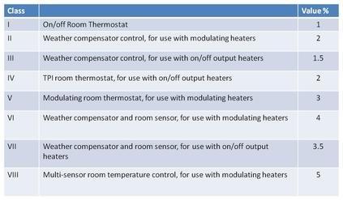

Suppliers placing temperature controls on the market and/or putting them into service must provide a product fiche, as defined in the regulation.
This must include:
a. The supplier's name or trade mark;
b. The supplier's model identifier;
c. The class of the temperature control;
d. The % contribution of the temperature control to seasonal space heating energy efficiency

