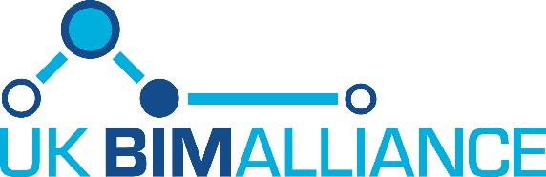

The Latest from the UK BIM Alliance
Keep up to date with what your UK BIM Alliance is doing to help drive BIM Level 2 as business as usual by 2020.



Alliance Forum Meeting

  We recently hosted the UK BIM Alliance Forum meeting on 14th September where we provided an update on what the UK BIM Alliance has been working on. Below are some of the highlights that were shared along with the minutes.
  The next meeting will be on 7th December in London, please register here if you wish to attend.
  All comments, feedback, suggestions are welcome, please send an email to us.

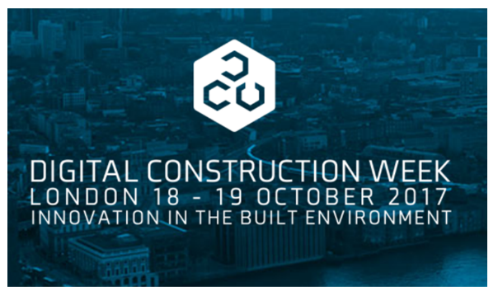

BIM Village & #BIMChats
The Alliance are running both the BIM Village theatre and #BIMChats classroom at Digital Construction Week. Read more here

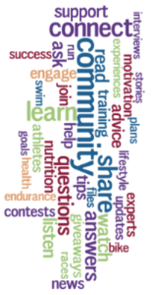

Communities
The Alliance communities team can be contacted here who can help connect you with the right people.
We are providing free access to all the communities via our website here; if your BIM4 group or BIM Region isn't listed please let the Communities team know.

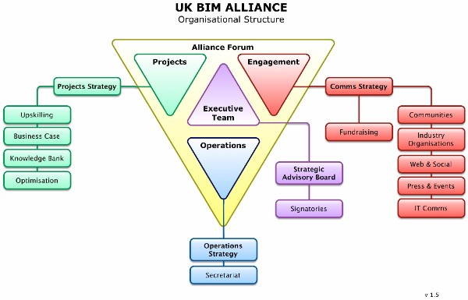

Organisation Structure
As a reminder we shared the organisation structure of the Alliance along with our vision, mission and goal. You can read more here

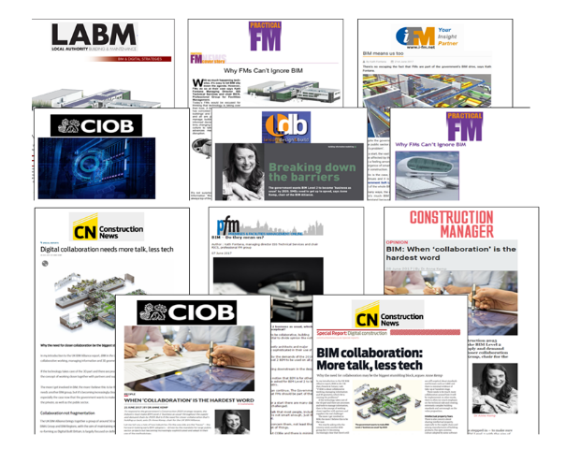

Social Media/PR
Our reach on Twitter and LinkedIn has grown with our numbers exceeding the industry standard. Over 20 articles placed within the media both reaching 1m+ online and over 550k in print
Keep Reading



Help Grow our KnowledgeBank
We all know of a good website, a great restaurant, an individual with thought provoking ideas and we are keen to tell the world of our online discoveries.
To make the case for BIM, we need to share our Projects in the same way. Please tell us about good BIM Case studies by adding them to the UKBIMA’s KnowledgeBank. Find out about the KnowledgeBank project here. Add your contribution here.

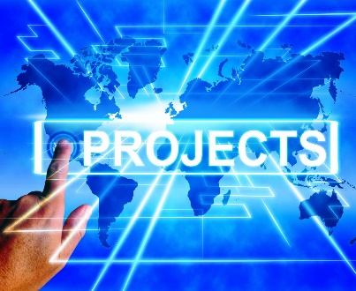

Projects Update
The latest news on the Data Requirements, Security Provisions, Knowledge Bank & Competency Framework projects can be found by clicking here



Help! We Need You!
We need your help with projects, with communities, events, industry organisations, operations. If you would like to get involved call or email the right person today

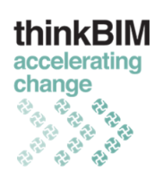

thinkBIM Roundtable
Why not share what you have been doing within your group? Or gather feedback to help take your activity to the next stage. thinkBIM are offering you the opportunity to host a round table at their event on Dec 6 - get in touch today.



Co-Creation Programme Launched
Process Innovation Forum has partnered with the UK BIM Alliance to launch the Co-Creation Programme and is asking you to get involved. Themes to be explored include VR, AR, drones, wearables, blockchains, project controls, legal, contractual, AI, skills and education and innovation management.
The Programme consists of a number of events including workshops, round-tables, talks and webinars with an aim to devising an “Open-Innovation Framework” for the Built Environment. Get involved.



Alliance Forum Minutes
We took minutes from our last Alliance Forum meeting which you can read here. You can also view the slides that were presented here.
Any feedback, comments, suggestions please email us.

