**Summary of BEIS consultations on future of RHI and low carbon heat**

Documents issued:

* [Web page summary](https://www.gov.uk/government/publications/changes-to-the-renewable-heat-incentive-rhi-schemes/changes-to-rhi-support-and-covid-19-response) of proposed changes including impact of Covid-19 on policy, and including those announced in the Budget of 11th March (inc extension of DRHI)
* Consultation document on changes to the NDRHI called [‘Ensuring a Sustainable Scheme’](https://www.gov.uk/government/consultations/non-domestic-renewable-heat-incentive-ensuring-a-sustainable-scheme)
* [Impact assessment](https://www.gov.uk/government/publications/changes-to-the-renewable-heat-incentive-rhi-schemes/changes-to-rhi-support-and-covid-19-response) for changes to both DRHI and NDRHI
* Consultation on the [‘Future Support for Low Carbon Heat’](https://www.gov.uk/government/consultations/future-support-for-low-carbon-heat) with proposals for direct support for heat pumps, initially between 2022-24
  + Also includes measures on biomass and biomethane
* [Impact assessment](https://www.gov.uk/government/consultations/future-support-for-low-carbon-heat) on ‘Future of Low Carbon Heat’ proposals
* Information on [biomethane research](https://www.gov.uk/government/publications/rhi-evaluation-evidence-report-biomethane-installations) and [biomass combustion in urban areas](https://www.gov.uk/government/consultations/renewable-heat-incentive-biomass-combustion-in-urban-areas) – *not summarised here as out of main BEAMA scope*

*Consultation deadlines: 7th July 2020.*

Summary of consultation proposals:

**Changes to the RHI for heat pumps proposed in the consultation**

* Govt hopes extension measures will support businesses and job creation in wake of Covid-19
  + Could be seen as a precedent for energy policy in the coming months
* Domestic RHI to be extended as promised in Budget of 11th March 2020
  + Will be open to new applicants until 31st March **2022**
  + No other changes to DRHI
* Non-Domestic RHI date announcements:
  + Deadline for new applications will remain 31st March **2021**
  + Flexible tariff guarantees will be available until this deadline when accompanied by Stage 2 information (extension of two months from current deadline)
  + Deadline for commissioning systems will be 31st March **2022**
    - Ofgem guidance on TGs available [here](https://www.ofgem.gov.uk/publications-and-updates/tariff-guarantee-applications)
* Proposals on shared ground loops:
  + Will allow shared ground loop systems to continue to modify capacity after the scheme closes to new applicants
  + Proposing a requirement that ‘the scheme administrator be provided with strong evidence clearly demonstrating the total planned capacity of the ground loop and their plans for bringing connecting heat pumps online at the point of accreditation’
    - Consultation question asks what evidence should be required
  + Where share ground loop systems supply only domestic properties but are registered under the NDRHI, e.g. in social housing projects, Govt is asking what changes should be made to future proof the scheme to ensure consumer protection
* Reporting requirements on Ofgem will be scaled back

**Future Support for Low Carbon Heat:**

* DRHI will be superseded from 2022 with a capital grant of £4,000 per installation
* There is a total budget cap of £100m, meaning 25,000 £4,000 grants are on offer over 2 years
* Aims of the grant are:
  + Up to 0.6 MtCO2e carbon savings over carbon budgets 4 and 5
  + Allow the heating (and green finance) industry to build and refine a “retail offer” to work alongside regulation.

Payment mechanism:

* Moving from tariff to grant based on consistent feedback including from BEAMA
* Technology-neutral, flat-rate grant of £4,000 (ie regardless of product type or cost)
  + States the onus is on the market to find which of these offers the most cost-effective low carbon technology for each property, but expect most will opt for ASHPs
* Voucher system paid directly to installer when installation is complete and when proof (e.g. MCS or equivalent certificate) is provided
* MCS certification or equivalent for products and installers, and installer membership of a consumer code, will be required for this scheme
* Seeking views on consumer protection risks and how they may be mitigated

Product scope and specification:

* GSHPs, ASHPs and WSHPs
* High and low temperature
* Not hybrids
* HPs of max 45kW – larger systems can be supported by other measures e.g. Industrial Energy Transformation Fund
  + Will not permit several <45kW HPs in the same residence/building, unless these each serve separate dwellings e.g. flats
* SCOP of at least 2.8 (uplift from 2.5 under RHI)
* Electricity metering to be required as it is under DRHI
* Biomass will be permitted under the grant scheme only in “hard to treat” properties
  + The aim is that biomass will not be eligible for support in a building that is suitable for a heat pump
  + This to be assessed with heat loss calculation, but Govt does not specify what they think the minimum heat loss value (W/m2) should be to permit biomass

Other issues:

Other issues:

* Notes non-financial barriers are being dealt with through other Government work, e.g. the electrification of heat demo project
* Ofgem will have the power to carry out on-site checks before a grant is paid, require corrective action and recoup grant payments if corrective action is not taken
* Govt ‘propose quarterly grant windows, each with a budget cap. This will help to maintain budget control over scheme costs, avoid intermittent deployment, and ensure that demand will be spread out across the year while keeping administration manageable. We believe that these measures will increase industry confidence in the scheme’s ability to support continued deployment of building-level technologies throughout its duration’.
  + In practice this will mean the budget is spread over the course of the initial 2 year period, with a set budget for each quarter year
  + Can be seen as way to avoid complicated degression measures, but does rely upon continuing awareness of the scheme throughout the two years and ensuring that applicants do not run out of patience if they are unable to achieve a grant initially
  + Also raises a question of whether a consumer will know if they can receive the grant before they place their order or have a completed installation

Impact Assessment for Future Support for Low Carbon Heat consultation:

We will also need to review the Impact Assessment in more detail but projected deployment is:

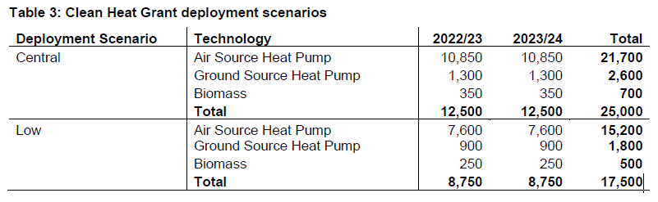

* The Green Gas scheme has a longer initial life span, with payments promised up to 2041 and rising to an average projected spend of around £120m per year each year between 2026 and 2041
* “Under central modelling assumptions, the Carbon Cost Effectiveness (CCE) is £67/tCO2e for the Green Gas Support Scheme and £25/tCO2e for the Clean Heat Grant”
  + While the scale of using green gas as part of the mains gas grid is high, the economies of scale are good, and the product costs are relatively lower than heat pumps, we can contend that heat pumps offer the only true low carbon heating option in this scheme.
* The Low Carbon Heating Grant is projected to have a positive impact on air quality, while the Green Gas Scheme is projected to have a negative impact on air quality
* Given the relative scales of the schemes, we should look closely at the impact assessment to understand this, and take a view on how we respond – do we welcome the grant as it is, or do we say it should have been more ambitious and larger scale in comparison to the green gas scheme?
* 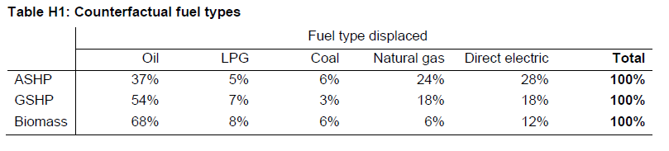This table projects what fuels will be replaced by clean heat, based on information from the RHI:
* There are product assumptions on heat pumps listed on page 44 of the Impact Assessment, listing expected capacity, cost, maintenance cost, lifetime etc.